**Assignment on Time Series Analysis & Forecasting**

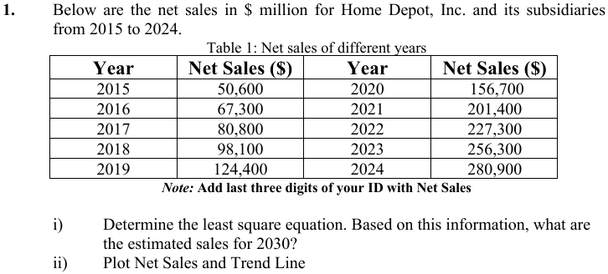

**Solution:**

|  |  |  |  |  |  |
| --- | --- | --- | --- | --- | --- |
| **Year** | **Net Sales (Y)** | **X** | **XY** | **XX** | **Yc** |
| 2015 | 50600004 | -9 | -455400036 | 81 | 32460003.97 |
| 2016 | 67300004 | -7 | -471100028 | 49 | 59553337.31 |
| 2017 | 80800004 | -5 | -404000020 | 25 | 86646670.65 |
| 2018 | 98100004 | -3 | -294300012 | 9 | 113740004 |
| 2019 | 124400004 | -1 | -124400004 | 1 | 140833337.3 |
| 2020 | 156700004 | 1 | 156700004 | 1 | 167926670.7 |
| 2021 | 201400004 | 3 | 604200012 | 9 | 195020004 |
| 2022 | 227300004 | 5 | 1136500020 | 25 | 222113337.4 |
| 2023 | 256300004 | 7 | 1794100028 | 49 | 249206670.7 |
| 2024 | 280900004 | 9 | 2528100036 | 81 | 276300004 |

Here, N=10; ∑y=1543800040; ∑xy = 4470400000; ∑x2 =330

We know,

a = $\frac{\sum{y}}{N}$ = $\frac{1543800040}{10}$ = **154380004**

**b=** = $\frac{\sum{xy}}{\sum{x^{2}}}$ = $\frac{4470400000}{330}$ = **13546666.67**

**Trend equation:**

Yc = a + bx

**For 2030, x = 21**

Then Y2023 = 154380004 + 13546666.67 * 21 = 438860004.1

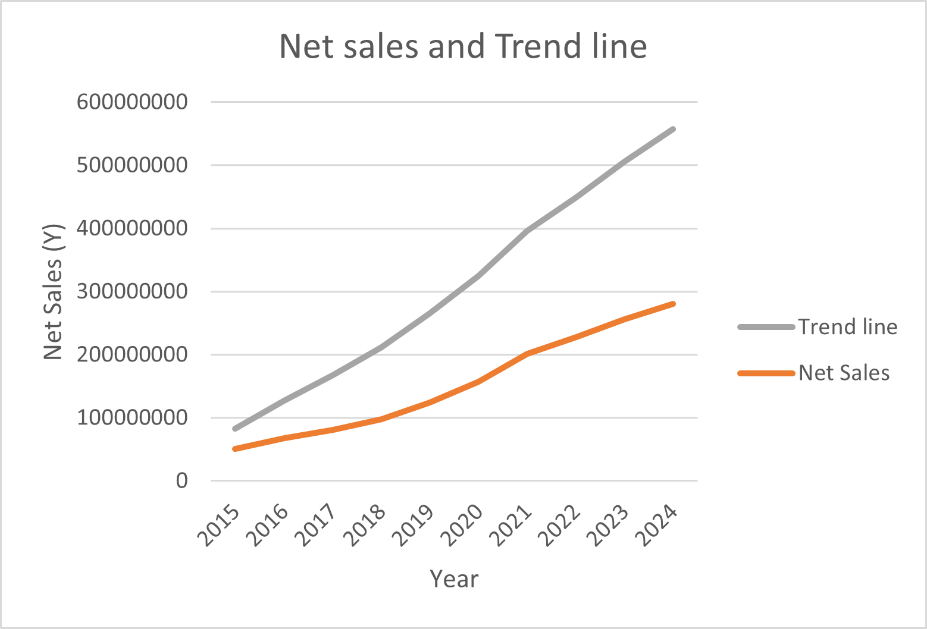

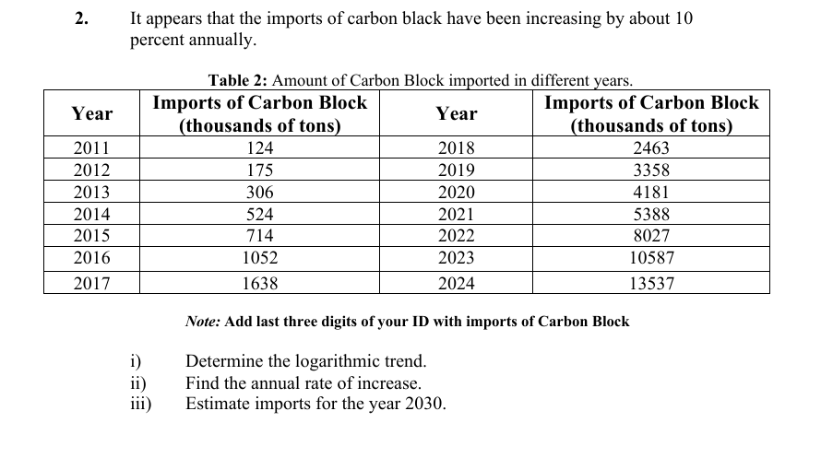

**Solution:**

|  |  |  |  |  |  |  |  |
| --- | --- | --- | --- | --- | --- | --- | --- |
| **Year** | **Imports of Carbon (Y)** | **x** | **xx** | **log(Y)** | **x log(y)** | **Log Yc** | **Yc** |
| 2011 | 124004 | -13 | 169 | 5.093436 | -66.2147 | 5.190542 | 155075.3 |
| 2012 | 175004 | -11 | 121 | 5.243048 | -57.6735 | 5.347631 | 222654.4 |
| 2013 | 306004 | -9 | 81 | 5.485727 | -49.3715 | 5.50472 | 319683.5 |
| 2014 | 524004 | -7 | 49 | 5.719335 | -40.0353 | 5.661809 | 458996.2 |
| 2015 | 714004 | -5 | 25 | 5.853701 | -29.2685 | 5.818898 | 659019.1 |
| 2016 | 1052004 | -3 | 9 | 6.022017 | -18.0661 | 5.975987 | 946208.5 |
| 2017 | 1638004 | -1 | 1 | 6.214315 | -6.21431 | 6.133076 | 1358550 |
| 2018 | 2463004 | 1 | 1 | 6.391465 | 6.391465 | 6.290165 | 1950584 |
| 2019 | 3358004 | 3 | 9 | 6.526081 | 19.57824 | 6.447253 | 2800615 |
| 2020 | 4181004 | 5 | 25 | 6.621281 | 33.1064 | 6.604342 | 4021077 |
| 2021 | 5388004 | 7 | 49 | 6.731428 | 47.12 | 6.761431 | 5773394 |
| 2022 | 8027004 | 9 | 81 | 6.904553 | 62.14098 | 6.91852 | 8289343 |
| 2023 | 10587004 | 11 | 121 | 7.024773 | 77.2725 | 7.075609 | 11901699 |
| 2024 | 13537004 | 13 | 169 | 7.131523 | 92.70979 | 7.232698 | 17088260 |

Here, N=14; ∑logy= 86.9626823; ∑xlogy = 71.47543718; ∑x2 = 910

We know,

Log(a) = $\frac{\sum{logy}}{N}$ = $\frac{86.9626823}{14}$ = 6.211620164

**Log(b)=** = $\frac{\sum{xlogy}}{\sum{x^{2}}}$ = $\frac{4470400000}{910}$ = 0.078544436

**Trend equation:**

logY = log(a) + log(b)x

**For the year 2023, x= 25**

logY = = 6.211620164 + 0.078544436 * 25 = 8.175231

Y2030 = 149703193

**Annual rate of increase** = (eb -1) x 100%

= (e0.0785 -1) x 100%

= 8.1663 %

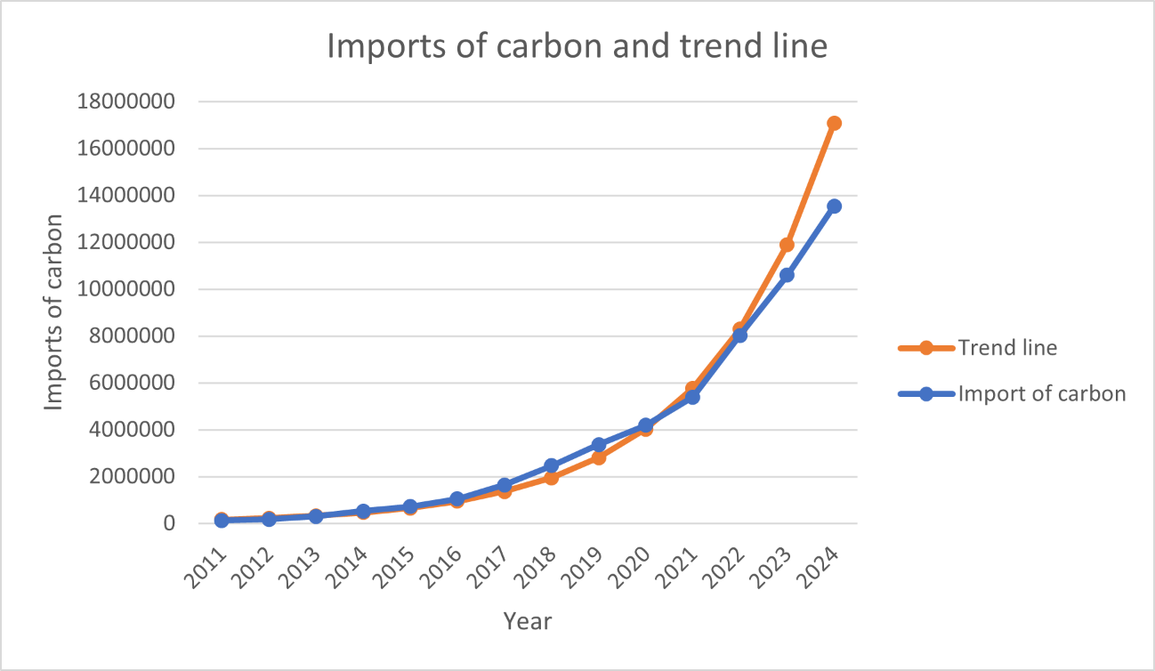

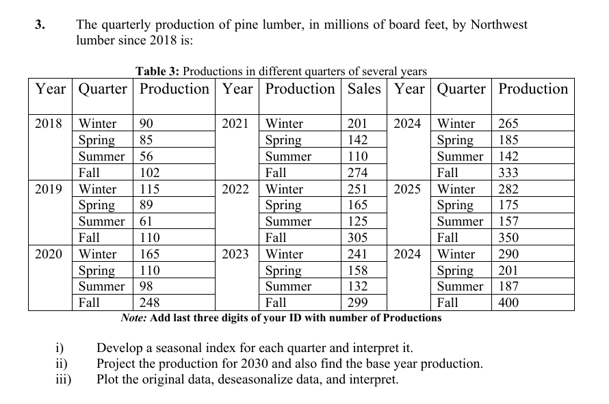

**Solution:**

|  |  |  |  |  |  |
| --- | --- | --- | --- | --- | --- |
| Year | Winter(production) | Spring(production) | Summer(production) | Fall(production) | Mean |
| 2018 | 90004 | 85004 | 56004 | 102004 | 83273 |
| 2019 | 115004 | 89004 | 61004 | 110004 | 93773 |
| 2020 | 165004 | 110004 | 98004 | 248004 | 155273 |
| 2021 | 201004 | 142004 | 110004 | 274004 | 181773 |
| 2022 | 251004 | 165004 | 125004 | 305004 | 211523 |
| 2023 | 241004 | 158004 | 132004 | 299004 | 207523 |
| 2024 | 265004 | 185004 | 142004 | 333004 | 231273 |
| 2025 | 282004 | 175004 | 157004 | 350004 | 241023 |
| 2026 | 290004 | 201004 | 187004 | 400004 | 269523 |

**Seasonal Index calculation:** Divide seasonal value of each year with the mean of each year. Then we get,

|  |  |  |  |  |
| --- | --- | --- | --- | --- |
| Year | Winter(production) | Spring(production) | Summer(production) | Fall(production) |
| 2018 | 1.081058686 | 1.021015215 | 0.67276308 | 1.225163018 |
| 2019 | 1.226611071 | 0.949345761 | 0.650752349 | 1.173290819 |
| 2020 | 1.06279263 | 0.708577795 | 0.631294559 | 1.597335016 |
| 2021 | 1.105901316 | 0.781320658 | 0.605276911 | 1.507501114 |
| 2022 | 1.186740922 | 0.78016575 | 0.591061019 | 1.442032309 |
| 2023 | 1.16142789 | 0.761472222 | 0.636184905 | 1.440914983 |
| 2024 | 1.145931432 | 0.80001989 | 0.614092436 | 1.439956242 |
| 2025 | 1.170108247 | 0.726167212 | 0.651485543 | 1.452238998 |
| 2026 | 1.076060299 | 0.745847293 | 0.693903674 | 1.484188733 |

Overall Seasonal Index:

|  |  |  |  |  |
| --- | --- | --- | --- | --- |
| Seasonal Index | Winter | Spring | Summer | Fall |
| SI | 1.135181388 | 0.808214644 | 0.638534942 | 1.418069026 |
| Sum of SI | 4 |  |  |  |

De-seasonalize data:

|  |  |  |  |  |
| --- | --- | --- | --- | --- |
| Year | Winter(production) | Spring(production) | Summer(production) | Fall(production) |
| 2018 | 79302.74486 | 105198.5393 | 87736.78045 | 71945.01688 |
| 2019 | 101325.657 | 110147.7196 | 95567.20549 | 77586.4912 |
| 2020 | 145371.4813 | 136130.9162 | 153512.3508 | 174901.9233 |
| 2021 | 177084.4749 | 175724.3587 | 172305.3709 | 193236.7149 |
| 2022 | 221130.2992 | 204182.1454 | 195796.646 | 215097.4279 |
| 2023 | 212321.1343 | 195521.0799 | 206759.2411 | 210866.3221 |
| 2024 | 233463.13 | 228928.047 | 222420.0912 | 234842.588 |
| 2025 | 248438.7103 | 216555.0962 | 245911.3663 | 246830.7209 |
| 2026 | 255486.0422 | 248724.7682 | 292893.9166 | 282089.9355 |

Production in 2030:

For winter

y = 22625x – 5E+07; for x = 2030 we get production = 35,928,750

For spring,

y = 18312x-4E+07; for x = 2030 we get production =

For summer,

y = 24066x-5E+07; for x = 2030 we get production =

For fall,

y = 24764 X - 4E+07; for x=2030 we get production =